Employee Self Service Quick Reference Card

Contents

Self Service Registration (Updated!) yes 2

Activate Your Email Address (Updated!) kimberlyclapp197@gmail.com 7

Activate Your Mobile Phone (Updated!)6788564877 8

Need Help? Forgot Your Password? 9

Need Help? Forgot Your User ID? 15

Self Service Registration (Updated!)

Welcome! ADP is committed to protecting your privacy and ensuring that only you can access your personal information. To assist us in meeting that commitment, you must register with us before using our services.

You will need your registration code (for example acme-abc1 or 9A7B632F) and the URL of your ADP service web site. Be sure to keep them handy.

On your ADP service web site, click the link to register for ADP services. Complete the following steps:

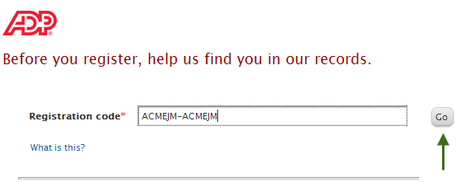

Enter Registration code.1545-0074

Ido not have this information, contact your organization's administrator for assistance.

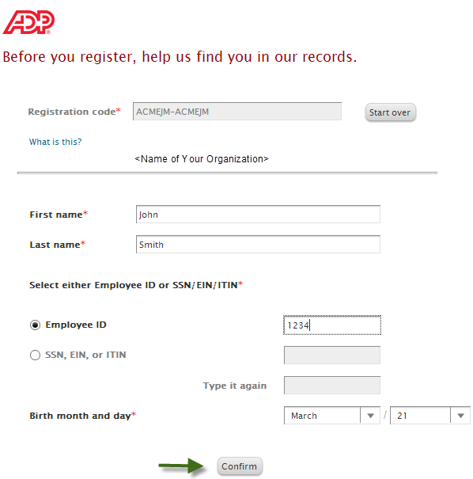

***Stacy l***

***Johnson***

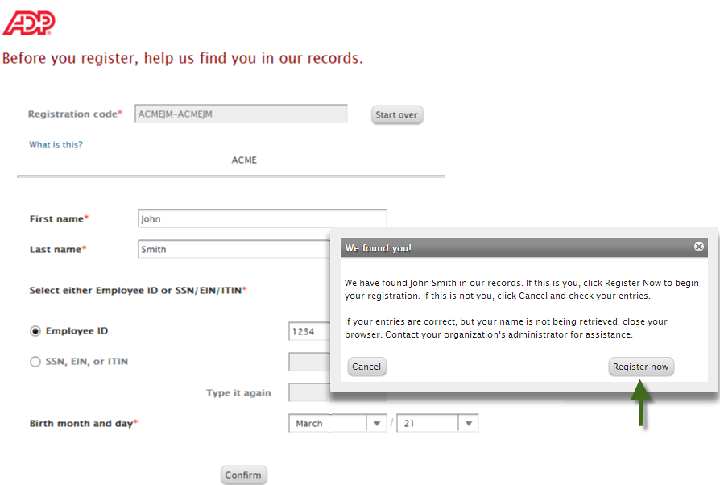

If your name is not being retrieved, contact your organization’s administrator for assistance.

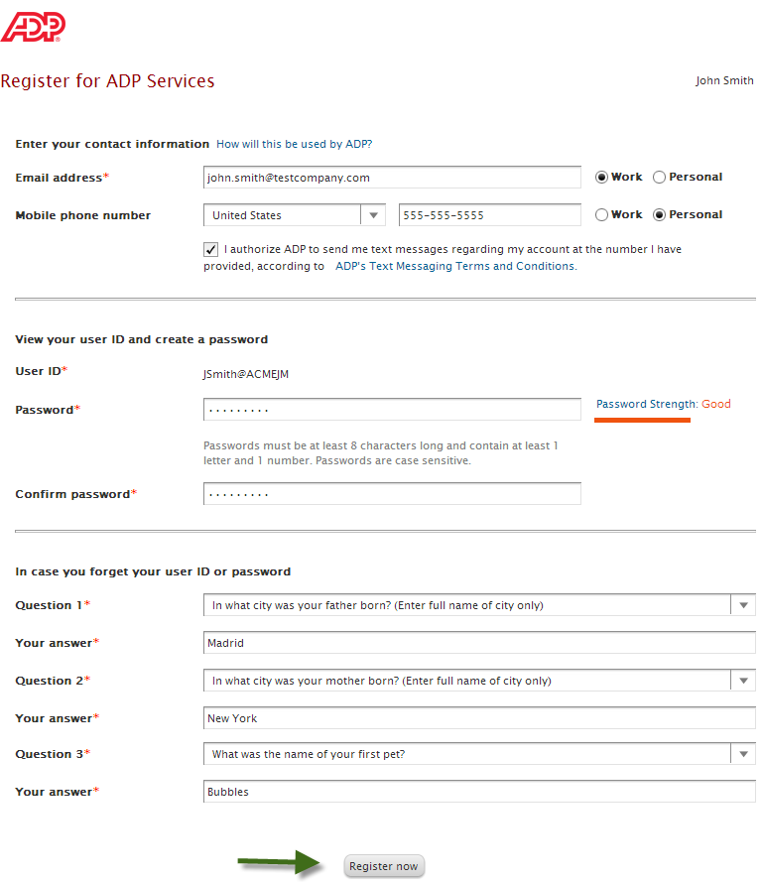

Create a strong password to protect your

account. Passwords are case-sensitive.

Your user ID and security answers are not case-sensitive.

Enter answers that you will remember later.

If you ever forget your user ID or password, you will be required to respond with the exact answers to confirm that you are the rightful owner of the account.

Depending on the ADP services your organization has purchased, the option to create your user ID might be available.

Notifications from your organization or ADP will be sent to this email/mobile phone. You may also use this information to retrieve your forgotten user ID or password.

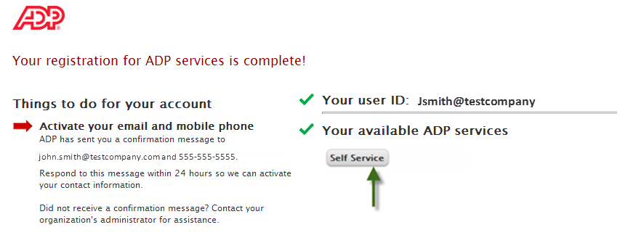

Your registration is complete. You can use your user ID and password to access your ADP service.

* You must activate your email and mobile phone number to receive important notifications from your organization or ADP.
* Manage your account information to keep it accurate.

Activate Your Email Address (Updated!)

Once you are registered, ADP will send you an email with instructions on how you can activate your email address. Click the link in the email you received from ADP to complete the activation.jstacy560@gmail.com

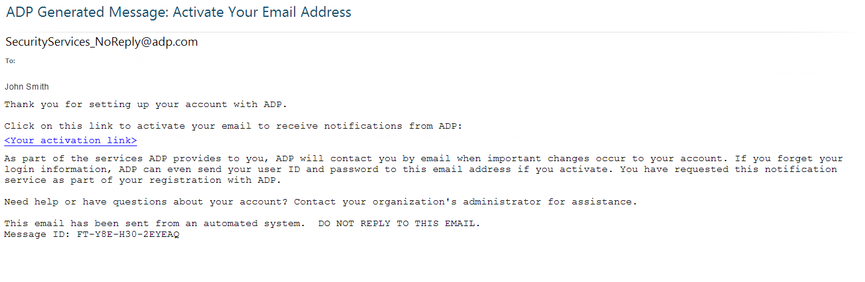

Jstacy560@gmail.com

Activate Your Mobile Phone (Updated!)

If you provided a mobile phone number during registration, look out for a text message from ADP. Reply with the code or follow the instructions in the text message to activate your mobile number. In the United States, the message will come from sender “90206”; the sender will vary in other countries.

Note: In some countries, this texting method to activate your mobile phone is not available, so your activation process will differ. Follow the instructions on the confirmation page and in the activation email you receive from ADP to complete the activation.6788564877

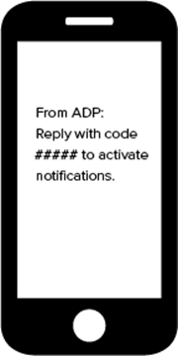

+16788564877

Need Help? Forgot Your Password?

Once registered, you can use your user ID and password to log in and access your ADP service. If you forget your password, you can use the “**Forgot your password**?” link on your ADP service web site to reset your password.

During this process, you will be required to verify that you are the rightful owner of the account to protect your personal information.

Complete the following steps.

1. Enter your user ID to identify yourself. SJOHNSON142@AMZN  
   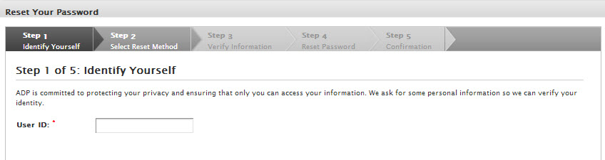
2. Select the reset method.Heartlover123
   * Request temporary password to be sent as a text message to your activated mobile phone number.
   * Request temporary password to be sent via email to your activated email address.
   * Request to answer security questions and reset the password on the screen.

**Note**: If you have not yet activated your email address and/or your mobile phone numbers, the email and text message options will not be available to you. Use the option to reset your password on the screen.  
  
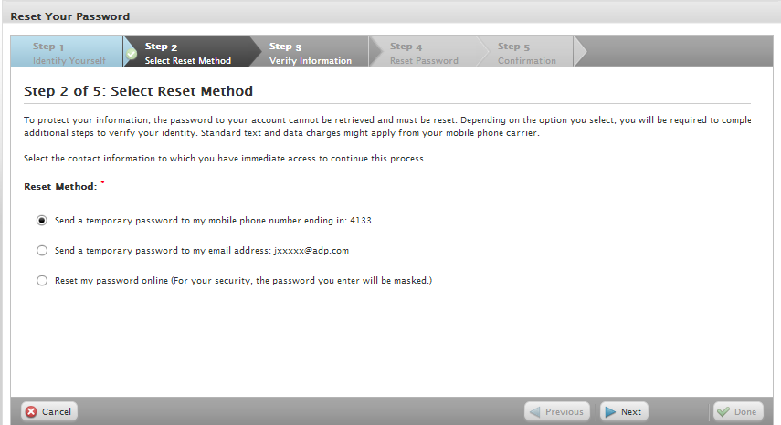

Note: Depending on the reset method you select, the next set of steps will differ.

**Using your activated mobile phone number or your email address**

1. Enter the answer to your security question(s) to continue.Bearlover

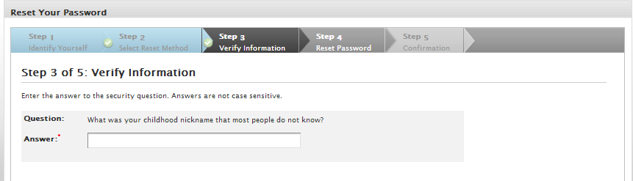

1. Upon successful verification of your security answer(s), a temporary password will be sent to your mobile phone number or email address.

Use your temporary password to log in to your ADP service and choose your new password when prompted. Heartlover123  
Note: If you are unable to reset your password, try a different option. If the problem persists, contact your organization’s administrator for assistance.

**Using the option to reset your password online**

1. Select the option to be asked identity questions on screen. (**Email notification) mobile number**

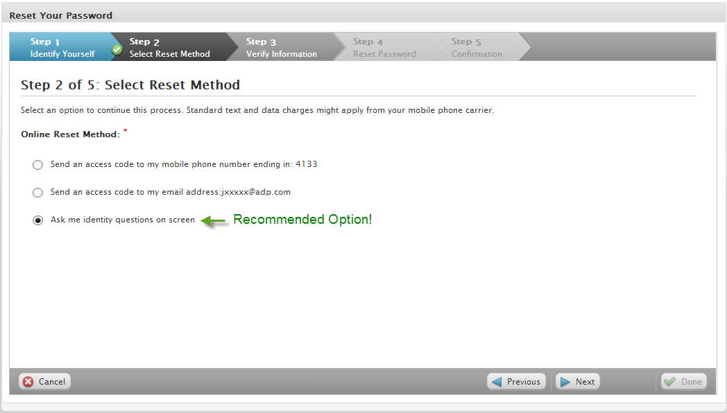2

1. Enter the identity verification information to confirm your identity.100343271 SSN.312784865  
   Important: The options on this page may vary based on the ADP services your organization has purchased.

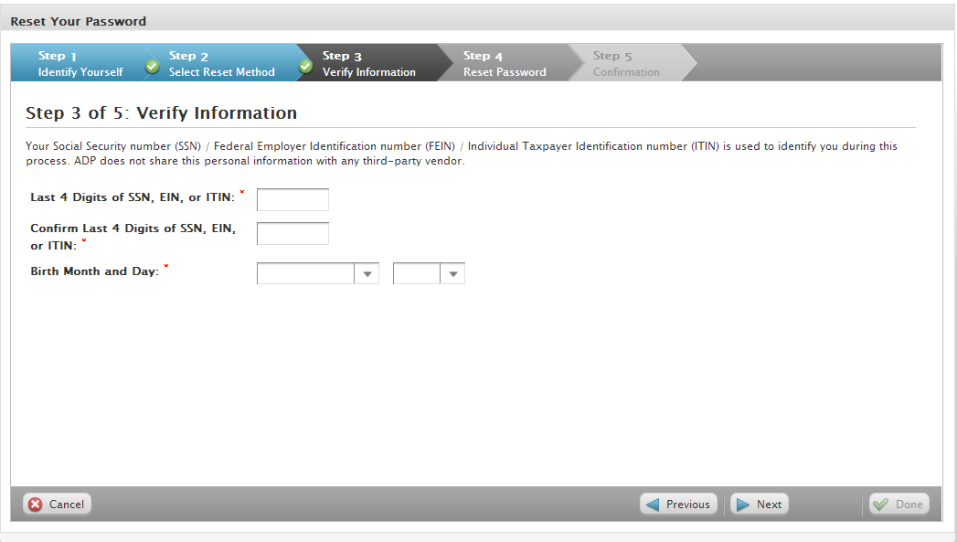

1. Enter answers to your security questions to continue. Bearlover



1. Upon successful verification of your security answers, you will be prompted to select and confirm your new password. Heartlover1234  
   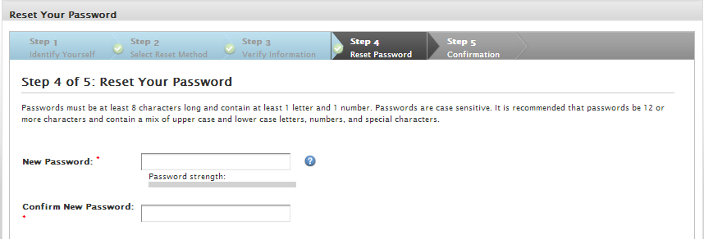

Congratulations! You have successfully reset your password. Use your new password to log in to your ADP service.  
Note: If you are unable to reset your password, try a different option. If the problem persists, contact your organization’s administrator for assistance.

Need Help? Forgot Your User ID?

Once registered, you can use your user ID and password to log in and access your ADP service. If you forget your user ID, you can use the “**Forgot your user ID**?” link on your ADP service web site to retrieve your user ID. During this process, you will be required to verify that you are the rightful owner of the account to protect your personal information.

Complete the following steps.

1. Enter your first name and last name exactly as they exist in your organization’s records. Enter an email address or mobile phone number associated with your account. Stacy (jstacy560@gmail.com)(6788564877)18:44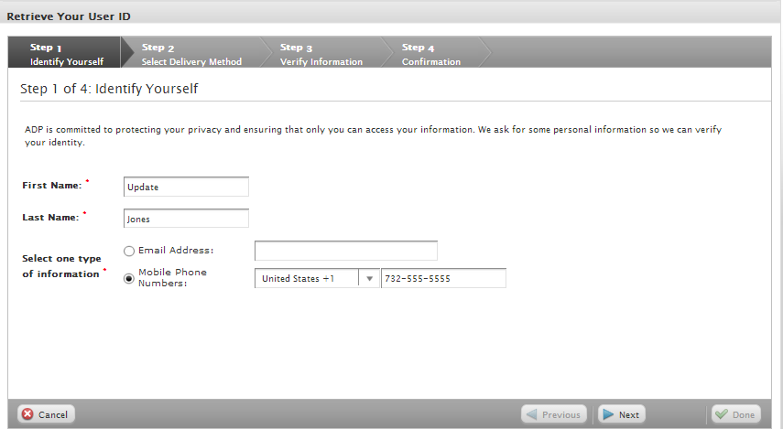
2. Select the delivery method to retrieve your user ID:
   * Request your user ID to be sent via email to your email address.jstacy560@gmail.com
   * Request your user ID to be sent as a text message to your mobile phone number.678856487
   * Request to answer a security question and retrieve your user ID on the screen.childhood nickname

**Note**: If your email is shared with other users in your organization, you must use the option to retrieve your user ID on the screen.  
  
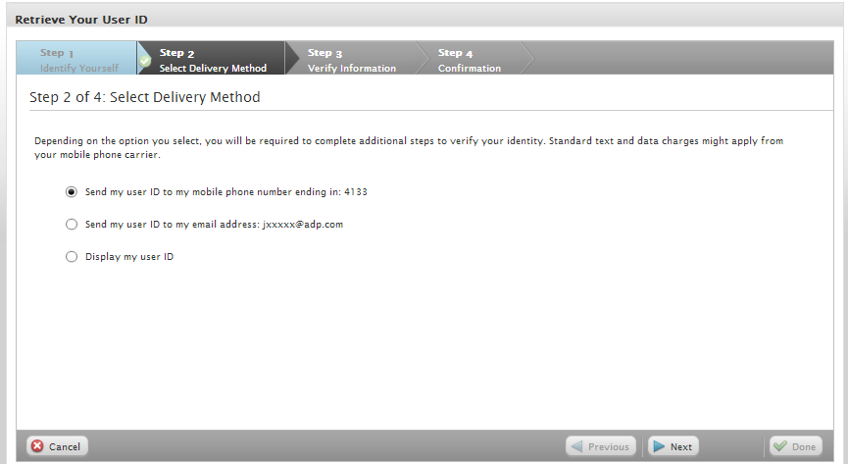Note: Depending on the method you select, the next set of steps will differ.

**Using your mobile phone number or your email address email address(**[**jstacy560@gmail.com**](mailto:jstacy560@gmail.com)**) mobile number(6788564877)**

1. Verify that your mobile phone / email address is correct. Your user ID will be sent to your mobile phone number or email address.  
     
   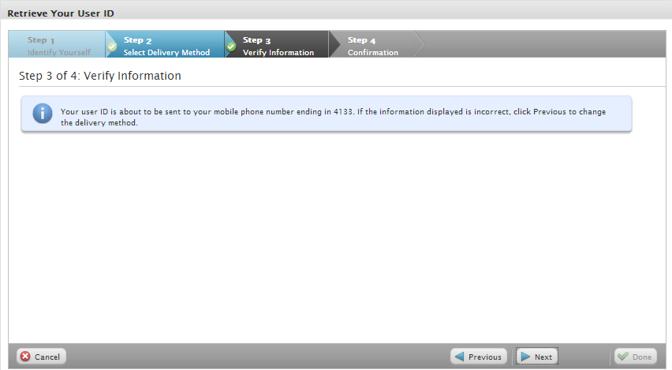

Congratulations! You have successfully retrieved your user ID. Use your user ID to log in to your ADP service account.  
Note: If you are unable to retrieve your user ID, try a different option. If the problem persists, contact your organization’s administrator for assistance.

**Using the option to display your user ID on the screen**

1. Enter the answer to your security question to continue. indiana

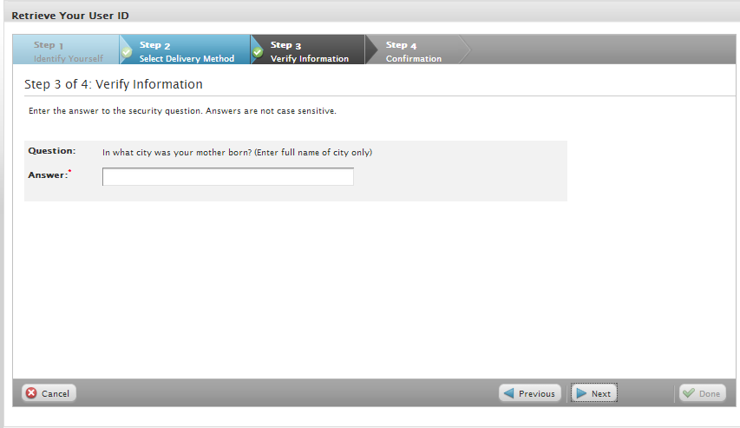

Upon successful verification of your security answer, your user ID will be displayed on the screen.

Congratulations! You have successfully retrieved your user ID. Use your user ID to log in to your ADP service account.  
Note: If you are unable to retrieve your user ID, try a different option. If the problem persists, contact your organization’s administrator for assistance.